**Estimating the House Price**

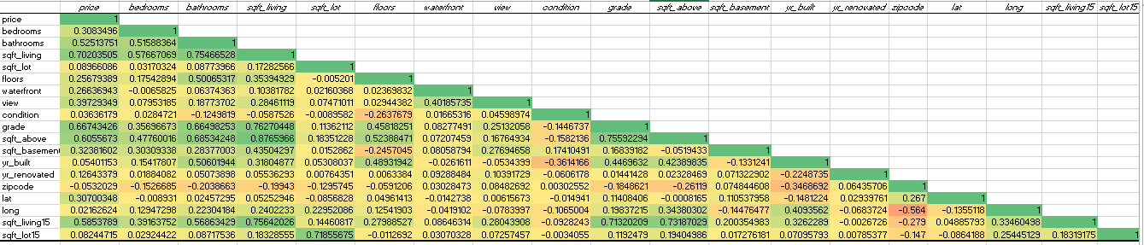

**Relationship between the variables from the above correlation matrix are:**

* The variables values which ranges from 0.7 – 1 shows strongly positive relation between

those variables.

* The values which ranges below 0.7 and above 0 shows weak positive relation between

those variables.

* The values which are below 0 shows negative relation between those variables.

**The variables sqft_living, grade, sqft_above, sqft_living15 are strongly co-related, based on these variables we**

**can estimate the price of the house.**

* Square feet of living space which includes bedrooms, bathrooms, living rooms and kitchen, based on

these we can estimate the price.

* Square feet above , the property with more above the ground square footage also involved in estimating

the price.

* Square feet living 15 means ceiling height, taller ceilings also considered in estimating the price.
* Grade means quality and condition of the property. Higher grade properties commands higher prices.